LAUNCH TOWER INSTRUCTIONS
Version: 20121012-001

Created By: Richard Witherspoon
Created Date: October 5th, 2012
Last Updated By: Richard Witherspoon
Updated Date: October 12th, 2012

Wireless Network Configuration
Channel: 802.11b – Ch1
SSID: psas
WPA-2: psasrocket
Router IP Address: 192.168.128.1
DHCP Range: .50 - .100
Static Range: .10 - .40

Original LTC Computer: 192.168.128.2/24

New LTC Computer: 192.168.128.250/24 (wireless)
192.168.128.251/24 (wired)

Access point
IP Address: 192.168.128.1
Username: admin
Password: psaslv1b
(if password doesn’t work – try leaving it blank)
BASIC SETUP

Tools Needed
- Miniature flathead screwdriver
- Miniature flathead screwdriver
- Large Phillips screwdriver

MOUNTING
Mount LTC box to already-standing launch tower [graphic]
Turn “side bulkhead” POWER and ARMING switches to “OFF” position [graphic]
Place breaker-bar in LTC [graphic]
Remove bottom plate cover from cable enclosure [graphic]

POWER CABLE ROUTING
Note: Run each powerpole connector one at a time and they will fit through opening. If you attempt to run all three at once – they will not fit.

Run Ignite leads through “bottom bulkhead” opening “A” and connect to 3&4
Run Battery leads though “bottom bulkhead” opening “A” and connect to 1&2
Run Solar Panel leads through “bottom bulkhead” opening “A” and connect to 5&6

DATA CABLE ROUTING
Connect rocket umbilical to “bottom bulkhead” receptor “B”
Connect sensor data cable into “bottom bulkhead” receptor “C”
Connect Wireless antenna cable to “bottom bulkhead” receptor “D”

INITIALIZING
Turn “side bulkhead” Power switch to “ON”

Look for lights on devices to indicate operation
- L7/L8/L9 should be flashing
- L2/L6 should light
Note: if no lights – immediately turn off power and troubleshoot

Replace bottom plate cover onto cable enclosure
Begin login process for testing checkout
LOGIN

Open Telnet / SSH session

Ip Address (wireless): 192.168.128.250
Ip Address (wired): 192.168.128.251

Instructions fer setting up wifi
https://help.ubuntu.com/community/WifiDocs/WiFiHowTo

sudo /etc/init.d/networking stop
sudo /etc/init.d/networking start

START-UP
- Power up the BeagleBoard
- Begin pinging the IP address of the BeagleBoard to determine when up. (Currently: 192.168.128.250)
- Connect via SSH to BeagleBoard
- Login as root user
  - Username: root
  - Password: psaslv1b
- Start the Phidget web service (verbose)
  - Because verbose flag any additional root control will require a separate SSH connection
  - /phidgetwebservice/phidgetwebservice21 -v

Start launch tower computer software

COMMON COMMANDS

Reboot Computer Instantly
# reboot –t now

Turn off computer instantly
# poweroff –t now

View IP Addresses assigned to interfaces
# ip address show
INTERNAL CONNECTIONS

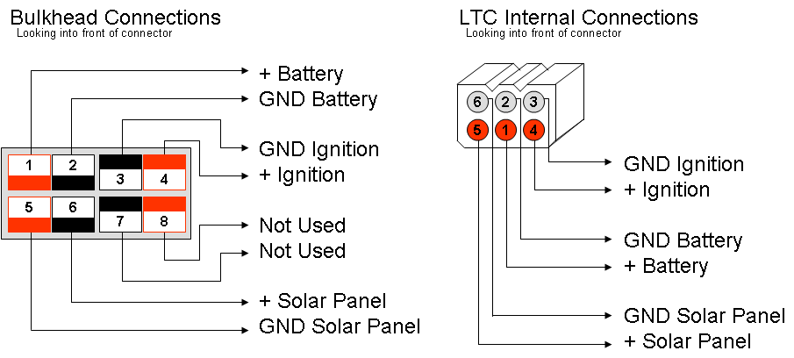

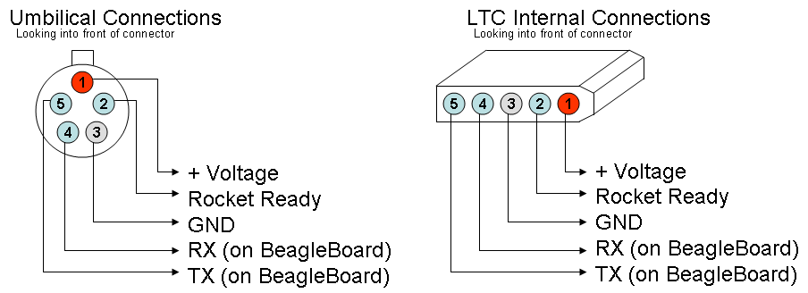

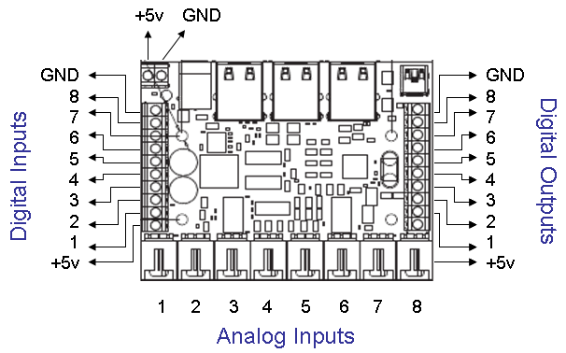

INTERNAL ROUTING

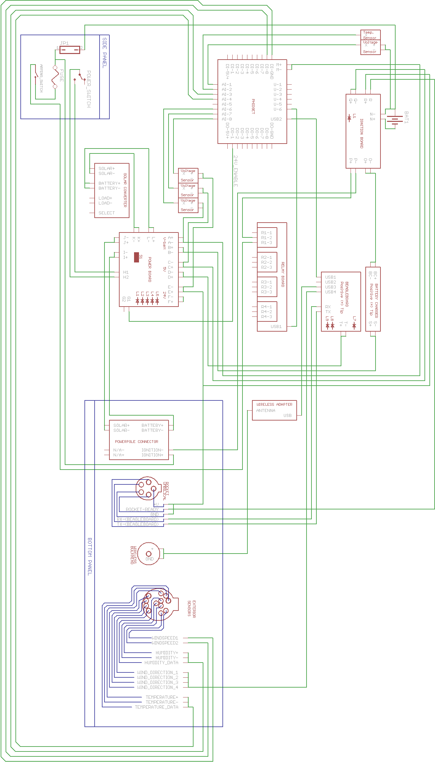

BOTTOM BULKHEAD

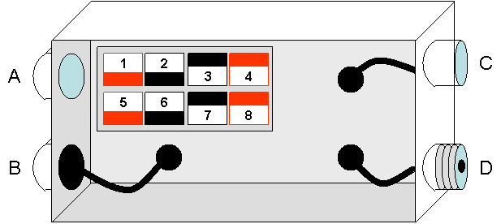

SIDE BULKHEAD

[picture needed]

[END OF DOCUMENT]

Launch Tower Computer
Diagnostic Test Procedures
Created By: Richard Witherspoon
Created Date: October 5th, 2012
Last Updated By: n/a
Updated Date: n/a

INITIAL SETUP

Disconnect: R± M± S T Q±
I± J± K± L± ← all of these don’t connect devices like batteries and solar panel to the exterior connection
N (to battery) O (to charger)
S2 to “OFF”

TEST MAIN POWER SWITCH

S2 to “OFF”
Continuity test across both H points
[PASS] Have NO continuity across points
[FAIL] Have continuity across points

S2 to “ON”
[PASS] Have continuity across points
[FAIL] Have NO continuity across points
S2 to “OFF”

TEST SOLAR PANEL CONNECTION AND LIGHTS

S2 to “OFF”
Connect 9-16V_{DC} (V_{INPUT}) to J±
[PASS] L1 light is ON
[FAIL] L1 light is OFF

Depress and hold S1
[PASS] L1 light is OFF
[FAIL] L1 light is ON
S2 to “OFF”

TEST SYSTEM BATTERY CONNECTION AND LIGHTS

S2 to “OFF”
Connect 9-16V_{DC} (V_{INPUT}) to I± or L±
[PASS] L2 light is ON
[FAIL] L2 light is OFF
S2 to “OFF”

S2 to “ON”
[PASS] L3 and L4 and L5 light is ON
[FAIL] L3 and L4 and L5 light is OFF
S2 to “OFF”

TEST POWER CONVERSION

S2 to “OFF”
Connect 9-16V_{DC} (V_{INPUT}) to I± or L±
S2 to “ON”
Voltage Check: A± B± C± D± E± F±
 | A± and B± | C± and D± | E± and F±
[PASS] | (V_{INPUT}) ± .02V | 5V ± .02V | 24V ± .02V
[FAIL] | != PASS | != PASS | != PASS

S2 to “OFF”

TEST PHIDGET BOARD

S2 to “OFF”
Connect: M±
S2 to “ON”
Voltage Check: M±
[PASS] Voltage = (V_{INPUT}) ± .02V
[FAIL] Voltage ! = (V_{INPUT}) ± .02V
Note: Ok if L5 goes out. This indicates Phidget board has turned off 24v converter.
S2 to “OFF”

TEST IGNITION BOARD

:: BOARD POWER ::
S2 to “OFF”
Connect: Q±
S2 to “ON”
Voltage Check: Q±
[PASS] Voltage = 5V ± .02V and L6 is ON
[FAIL] Voltage != 5V ± .02V or L6 is OFF
S2 to “OFF”

:: SHORE POWER ::
Disconnect: M±
Connect: R+
S2 to “ON”
Voltage Check: R+ / Q-
[PASS] Voltage = 24V ± .02V and L5 is ON
[FAIL] Voltage != 24V ± .02V or L5 is OFF
S2 to “OFF”
Re-Connect: M±

:: IGNITION BATTERY ::

NEED PROCEDURE HERE

TEST IGNITION BATTERY CHARGER

S2 to “OFF”
S2 to “ON”
Voltage Check: S (positive tip)
[PASS] Voltage = (V_{INPUT}) ± .02V
[FAIL] Voltage != (V_{INPUT}) ± .02V
Connect: S
[PASS] Battery charger turns on
[FAIL] Battery charger does NOT turn on

Note: If charger display shows “Er2” – it indicates the input voltage on S is greater than the 16V maximum input of charger.
S2 to “OFF”

TEST BEAGLEBOARD
S2 to “OFF”
S2 to “ON”
Voltage Check: T (positive tip)
[PASS] Voltage = 5V ± .02V
[FAIL] Voltage != 5V ± .02V
Connect: T
[PASS] L7 is ON and L8 and L9 start flashing
[FAIL] L7 is OFF or L7 is RED

Note: Failure at this stage may indicate the polarity is revered on connection

Note: At this stage it may not be a good idea to turn S2 to “OFF” because it could corrupt the beagleboard image. Instead, let computer boot – connect to it and power down the board normally.
S2 to “OFF”

[END OF DOCUMENT]

